Mini Centrifuge—MC6000

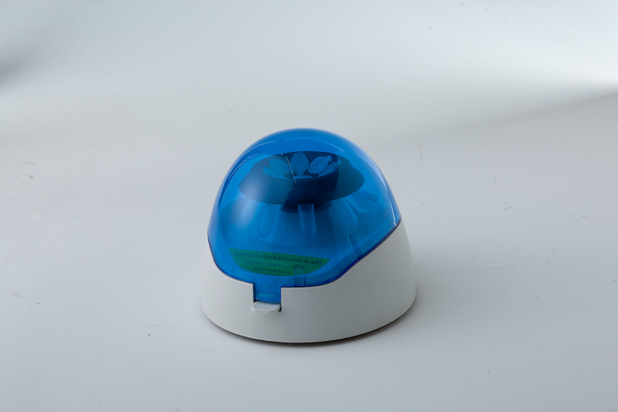
Description:
MC6000 Mini-centrifuge standard configuration include two rotors:
8x1.5ml rotors max accommodate 8x 1.5/2.0ml centrifuge tubes; if use random equipped with 0.2ml or 0.5ml tube sets, also can use 0.2ml or 0.5ml tubes on this product:
4x8x0.2ml rotors accommodate 4x8 x0.2ml PCR special tubes.
Two kinds of rotors are both can be used in experiments on micro centrifugation, cell separation and quickly separating from the test tube wall and etc.

Features:
- Small volume, light weight
- 1.5ml rotors accommodate 8x1.5/2.0/0.5/0.2ml centrifugal test tubes.
- 8-place rotors accommodate 32x0.2ml centrifugal test tubes.
- use flip type switch function, automatically stop when open the cover, the cover is made by composite material which in not easy broken.

Parameters:
Type  Parameter | MC6000
Capacity(standard rotors) | 8x1.5/2.0/0.5/0.2ml
Capacity(8-place rotors) | 4x8x0.2ml
Speed | 6000rpm
Max(RCF) | 2000g
Voltage | AC100-240V, 50/60Hz
Power | ≤50W
Dimension(mm) | 160×150×125
Weight(kg) | 0.9

